**Lesson 06 Demo 01**

**Facilitating Language Conversion Using Generative AI**

**Objective:** To demonstrate the migration of the login functionality of an online retail platform from Java to JavaScript

**Tools required:** ChatGPT, Visual Studio, and GitHub Copilot

**Prerequisites:** Install MySQL in your system

Steps to be followed:

1. Convert the login functionality written in Java to JavaScript

**Step 1: Convert the login functionality written in Java to JavaScript**

* 1. Install MySQL and run it on the local machine. Create a database to store user data

Database Name: RetailPlatform

**Below command is use to create the database**

**create database RetailPlatform;**

**Below command is use to move or switch inside a database.**

**use RetailPlatform;**

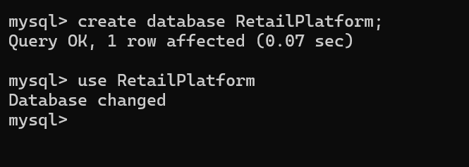

**Now we will create the table**

Table Name: users

**create table users(**

**emailId varchar(25) primary key,**

**password varchar(25));**

Insert some test data directly via MySQL as follows:

**INSERT INTO users (emailId, password) VALUES**

**('admin@gmail.com', 'admin@123'),**

**('user1@gmail.com', 'user1@123');**

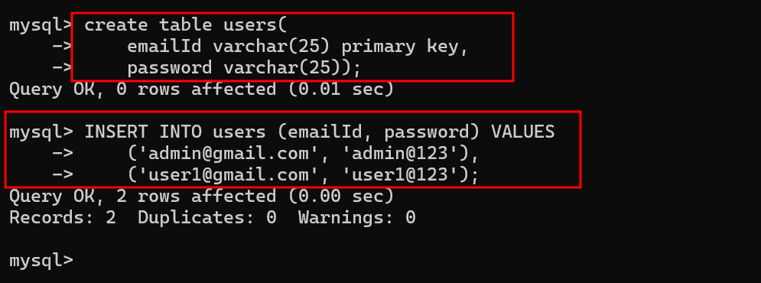

* 1. Download Java Project folder RetailPlatform_java_app, extract and open inside a VS code Editor

After open you can see the project structure as

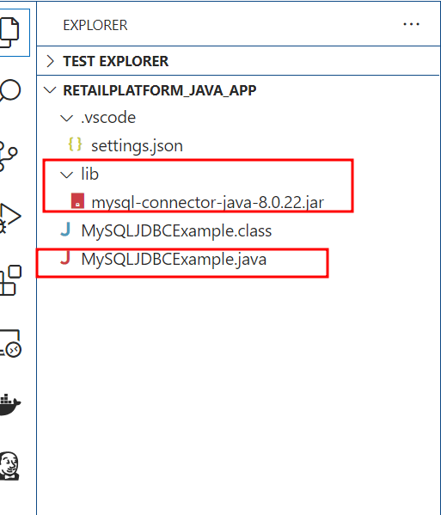

**MySQLJDBCExample.java** code

// Source code is decompiled from a .class file using FernFlower decompiler.

import java.sql.Connection;

import java.sql.DriverManager;

import java.sql.PreparedStatement;

import java.sql.ResultSet;

import java.sql.SQLException;

import java.util.Scanner;

public class MyJavaFile {

   private Connection connection;

   public MyJavaFile() {

      try {

         System.out.println("I came her");

         this.connection = DriverManager.getConnection("jdbc:mysql://localhost:3306/RetailPlatform", "root", "root@123");

         System.out.println("Connected to MySQL database!");

      } catch (Exception var2) {

         System.out.println("Error connecting to MySQL: " + var2);

      }

   }

   public static void main(String[] var0) {

      MyJavaFile var1 = new MyJavaFile();

      Scanner var2 = new Scanner(System.in);

      System.out.print("Enter emailId: ");

      String var3 = var2.nextLine();

      System.out.print("Enter password: ");

      String var4 = var2.nextLine();

      if (var1.authenticate(var3, var4)) {

         System.out.println("Login successful!");

      } else {

         System.out.println("Login failed!");

      }

      var2.close();

   }

   private boolean authenticate(String var1, String var2) {

      if (this.connection == null) {

         System.out.println("MySQL connection not established");

         return false;

      } else {

         PreparedStatement var3 = null;

         ResultSet var4 = null;

         try {

            String var5 = "SELECT * FROM users WHERE emailId = ? AND password = ?";

            var3 = this.connection.prepareStatement(var5);

            var3.setString(1, var1);

            var3.setString(2, var2);

            var4 = var3.executeQuery();

            boolean var6 = var4.next();

            return var6;

         } catch (SQLException var16) {

            System.out.println("Error executing SQL query: " + var16.getMessage());

         } finally {

            try {

               if (var4 != null) {

                  var4.close();

               }

               if (var3 != null) {

                  var3.close();

               }

            } catch (SQLException var15) {

               System.out.println("Error closing resources: " + var15.getMessage());

            }

         }

         return false;

      }

   }

}

In the file change your database name, username and password depending upon MySQL Database configuration details

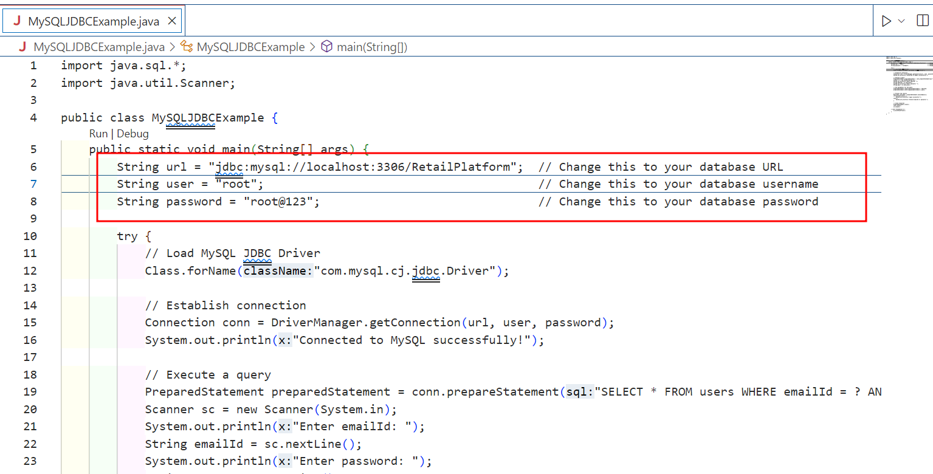

Run the following Java code in Visual studio code to connect with MySQL to perform authentication:

Then click on run option

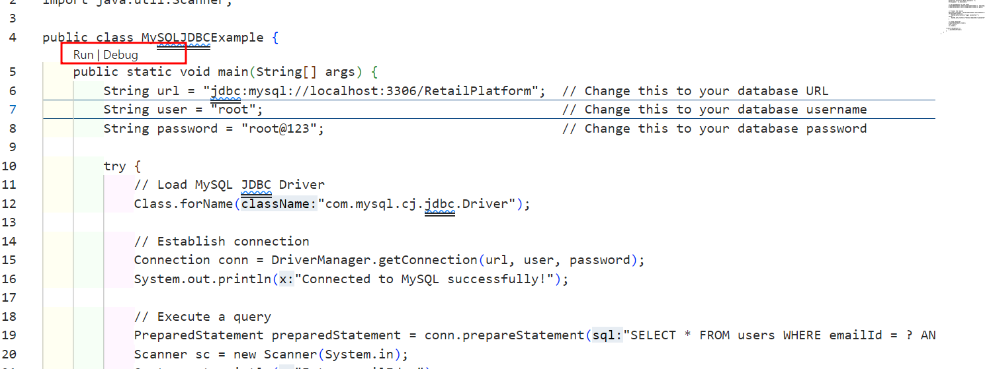

It will ask you emailId and password

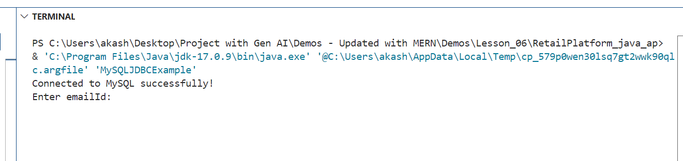

[admin@gmail.com](mailto:admin@gmail.com) as emailid

admin@123 as password

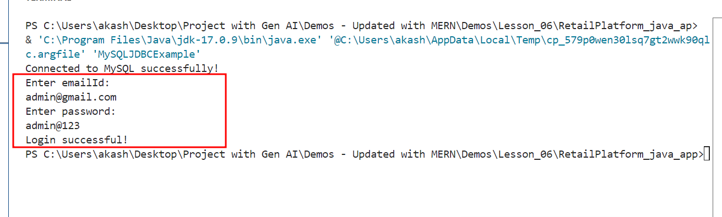

If you run once again with wrong emailid and password.

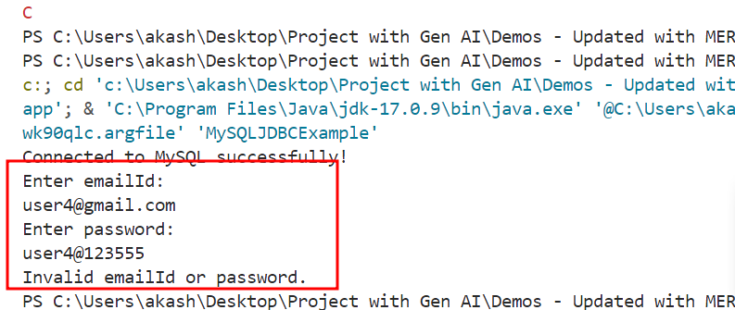

* 1. Install the GitHub Copilot extension. Once it is installed, it appears as follows:

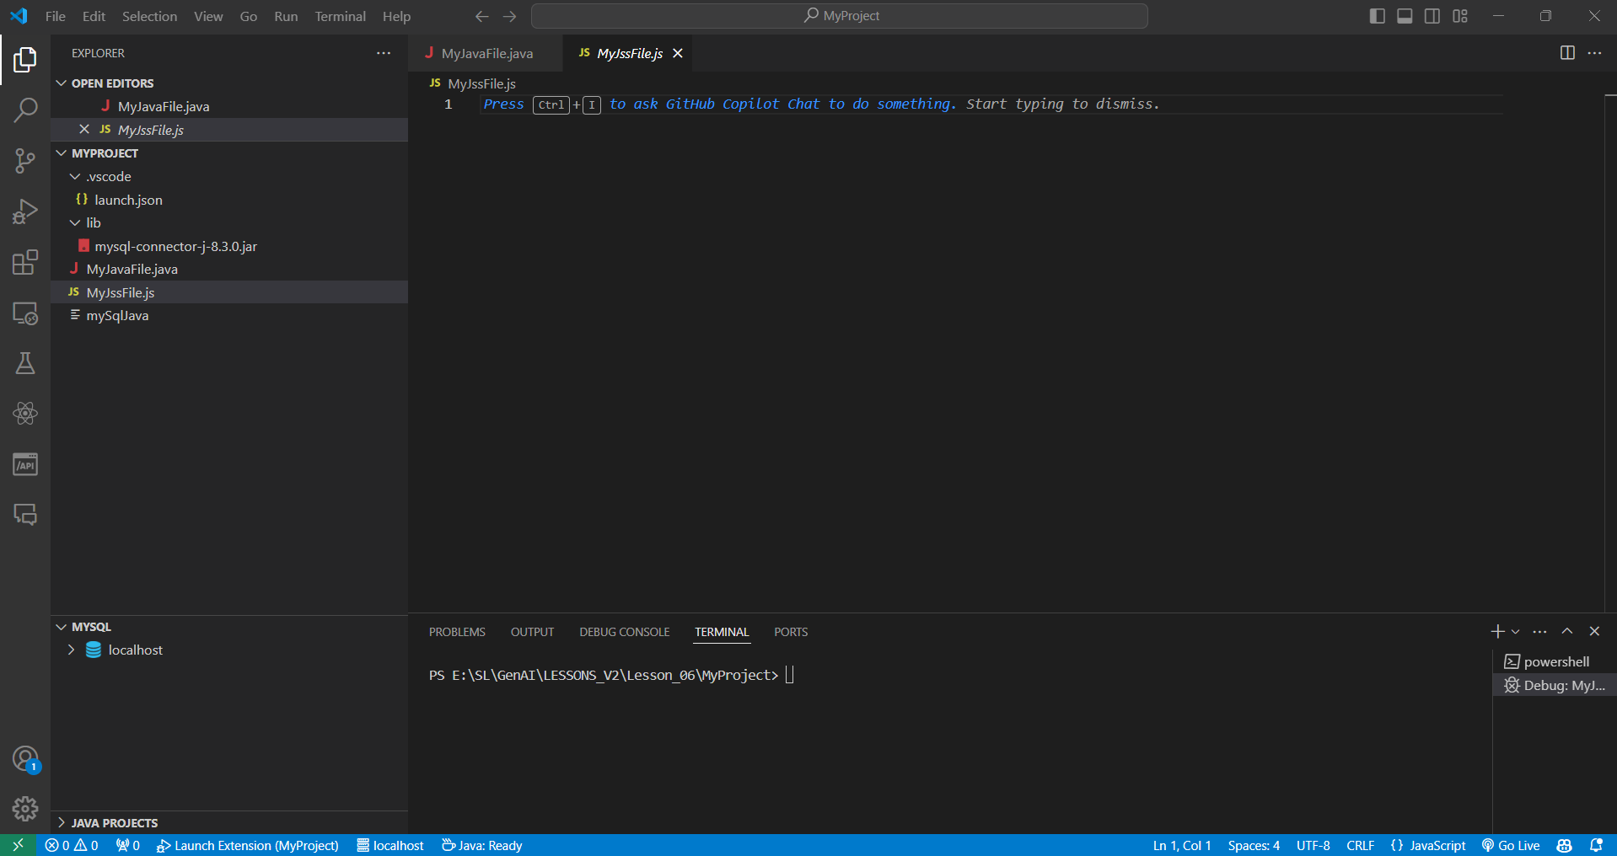

* 1. Use **Ctrl+I** to open the GitHub Copilot prompt
  2. Use the following prompt along with the Java code to convert it into JavaScript:  
     **Convert the provided java code, which interacts with a MySQL database to JavaScript using Node.js and the mysql package**

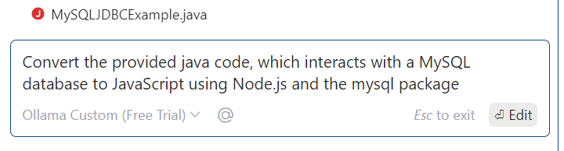

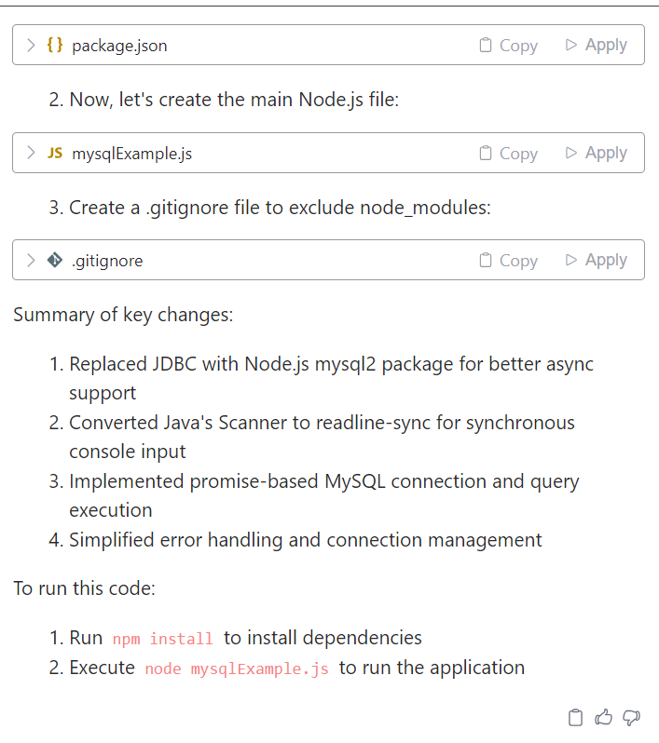

* 1. apply all these changes or follow the instruction which help to create Java Code into node js to connect mysql database.

**Summary of key changes:**

Replaced JDBC with Node.js mysql2 package for better async support

Converted Java's Scanner to readline-sync for synchronous console input

Implemented promise-based MySQL connection and query execution

Simplified error handling and connection management

To run this code:

Run **npm install** to install dependencies

Execute **node mysqlExample.js** to run the application

Open the external terminal and execute above two commands.

* 1. Execute the converted JavaScript code and verify the output of both Java and converted JavaScript using the following command:

